IBM AML – Transaction and Fraud Analysis Dashboard Using Power BI
REPORT

PANUGANTI SUNETHRA
E25FA032
BCOM FINTECH & AI

IBM AML – Transaction and Fraud Analysis Dashboard Using Power BI

1. Introduction
Power BI is a business intelligence and data visualization tool used to analyse data and create interactive dashboards. This project uses Power BI to analyse banking transactions, account details and fraud alerts from the IBM Anti-Money Laundering (AML) dataset.
The main objective of this activity is to identify fraudulent transactions, understand transaction patterns over time, analyse account balances and help management make better financial decisions.

2. Dataset Overview
Three CSV files were imported into one Power BI file (IBM AML.pbix).
Table | Rows | Columns | What it contains
accounts | 10,000 | 7 | ACCOUNT_ID, CUSTOMER_ID, INIT_BALANCE, COUNTRY, ACCOUNT_TYPE, IS_FRAUD, TX_BEHAVIOR_ID
transactions | 1,323,234 | 8 | TX_ID, SENDER_ACCOUNT_ID, RECEIVER_ACCOUNT_ID, TX_TYPE, TX_AMOUNT, TIMESTAMP, IS_FRAUD, ALERT_ID
alerts | 1,719 | 9 | ALERT_ID, ALERT_TYPE, IS_FRAUD, TX_ID, SENDER_ACCOUNT_ID, RECEIVER_ACCOUNT_ID, TX_TYPE, TX_AMOUNT, TIMESTAMP

3. Steps Involved

Step 1: Importing the Dataset
- Open Power BI Desktop.
- Import the three CSV files: Accounts, Transactions and Alerts.
- Save the Power BI file as IBM AML.pbix.
- Check the imported data in Data View and Model View.
- Identify identifier fields (ACCOUNT_ID, TX_ID, ALERT_ID), category fields (ALERT_TYPE, TX_TYPE, IS_FRAUD), numerical fields (TX_AMOUNT, INIT_BALANCE) and the time field (TIMESTAMP).

Step 2: Data Inspection and Cleaning
- Open Power Query Editor.
- Promote the first row to headers and set the correct data type for every column (whole number, text, decimal number, True/False).
- In the Alerts table, standardise ALERT_TYPE using Replace Values (cycle to CYCLE and fan_in to FAN_IN).
- Run the checks given in the table below.

Check | Result
Null or blank Accounts[ACCOUNT_ID] | None. All 10,000 account IDs are filled and unique
Duplicate TX_ID in Transactions | None
Transactions[ALERT_ID] = -1 | 1,321,515 transactions. This means no alert was raised, so the value is kept without replacing it
Repeated ALERT_ID in Alerts | Allowed. 1,719 alert rows share 391 distinct ALERT_IDs, because one alert can cover many transactions
Negative amounts or balances | None. INIT_BALANCE ranges from 100 to 599.60
Unusually large amounts | 15,911 transactions are above 1 million. 3,053 of them are exactly 21,474,836.47, which looks like a system maximum value
IS_FRAUD data type | True/False in all three tables
TIMESTAMP | Kept as a numeric field (0 to 199)

COUNTRY (US), ACCOUNT_TYPE (I) and TX_TYPE (TRANSFER) have only one value each, so they do not help in comparing groups.

Step 3: Creating Relationships
Create the following relationships using Manage Relationships:
From | To | Relationship | Cross-filter
Accounts[ACCOUNT_ID] | Transactions[SENDER_ACCOUNT_ID] | One-to-many (Active) | Single
Accounts[ACCOUNT_ID] | Transactions[RECEIVER_ACCOUNT_ID] | One-to-many (Inactive) | Single
Transactions[TX_ID] | Alerts[TX_ID] | One-to-many (Active) | Both

Only one relationship between two tables can be active, so the receiver relationship is kept inactive. The Transactions to Alerts relationship filters in both directions, which lets the Alert Type slicer (from the Alerts table) filter the transaction visuals.

Step 4: Creating DAX Measures
DAX measures are used to calculate important values from the dataset. Six measures were created.
Measure | DAX formula | Result
TOTAL TRANSACTION AMOUNT | SUM(Transactions[TX_AMOUNT]) | 153,479,506,204.98 (153.48bn)
Total Transactions | COUNT(Transactions[TX_ID]) | 1,323,234
Total Accounts | DISTINCTCOUNT(Accounts[ACCOUNT_ID]) | 10,000
Average Transaction Amount | AVERAGE(Transactions[TX_AMOUNT]) | 115,988.18
Total Initial Balance | SUM(Accounts[INIT_BALANCE]) | 2,801,186.33
Fraudulent Transactions | CALCULATE(COUNT(Transactions[TX_ID]), Transactions[IS_FRAUD] = TRUE()) | 1,719

After creating the measures, format them according to their values. Use Decimal Number for transaction amounts and Whole Number for transaction and account counts.

Step 5: Creating the Dashboard
Create the following visualizations in the Report view on the page AML TRANSACTION AND FRAUD ANALYSIS, with a bold title text box at the top.
- Card visuals: four cards showing Fraudulent Transactions, Total Transactions, Total Transaction Amount and Total Accounts.
- Line chart, Transaction Volume upon Timestamp: X-axis is TIMESTAMP and Y-axis is TOTAL TRANSACTION AMOUNT. It shows how the value moved over time.
- Donut chart, Transaction Distribution by Fraud Status: Legend is IS_FRAUD and Values is Total Transactions. It shows the share of fraudulent and non-fraudulent transactions.
- Line chart, Fraudulent Transactions Volume upon Timestamp: same axes as the first line chart, with a visual-level filter on IS_FRAUD = True. It helps to see the fraud pattern over time.
- Clustered bar chart, Alert by Alert Type: Y-axis is ALERT_TYPE and X-axis is the count of ALERT_ID. It shows the number of alerts under each category.
- Clustered column chart, Total Transaction Value by Fraud Status: X-axis is IS_FRAUD and Y-axis is TOTAL TRANSACTION AMOUNT. It compares transaction values of fraudulent and non-fraudulent transactions.
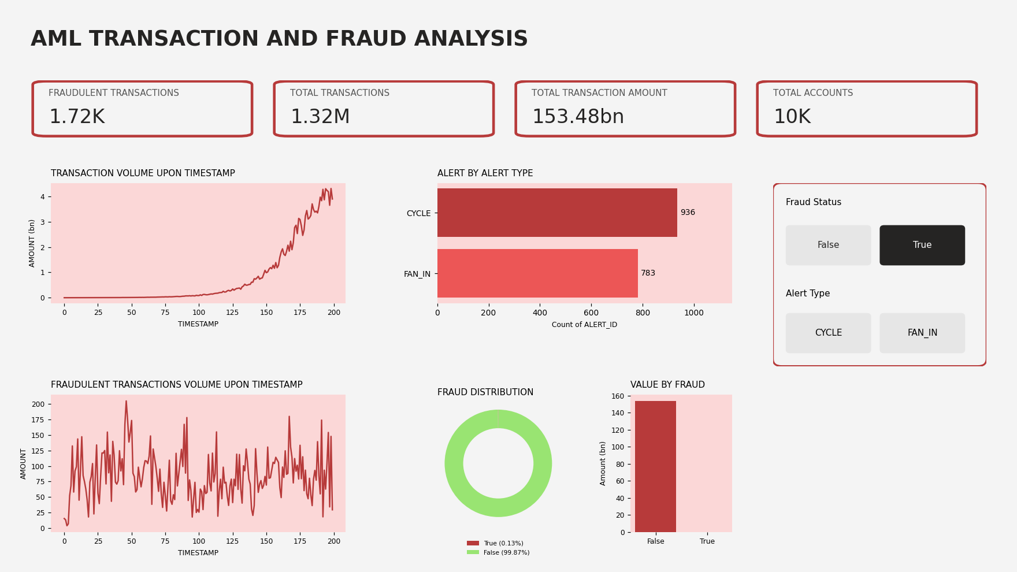
Figure 1: AML dashboard summary (charts redrawn from the dataset values)

Step 6: Creating an Interactive Dashboard
- Duplicate the existing AML Transaction & Fraud Analysis page.
- Rename the duplicated page as Interactive AML Dashboard.
- Keep the original dashboard unchanged.
- Rearrange the visualizations to create a clear layout: cards in one row at the top, charts below them and the slicers on the right side.

Step 7: Adding Slicers
Add two slicers to the Interactive AML Dashboard.
Slicer | Field | Purpose
Fraud Status | Transactions[IS_FRAUD] | Show only fraud or only non-fraud transactions
Alert Type | Alerts[ALERT_TYPE] | Show only CYCLE or only FAN_IN alerts

These slicers allow users to filter the dashboard based on fraud status and alert categories.

Step 8: Checking Visual Interactions
- Select the Fraud Status slicer.
- Open the Edit Interactions option.
- Check the Filter and None options for the different visuals.
- Ensure that the slicer affects only the required visuals.

Step 9: Creating a Tooltip Page
- Create a new report page and rename it as AML Tooltip.
- Change the page type to Tooltip and turn on Allow use as tooltip.
- Add three Card visuals: Total Transactions, Total Transaction Amount and Fraudulent Transactions.
- Return to the Interactive AML Dashboard and select the Transaction Volume upon Timestamp line chart.
- Enable Tooltips, select Report Page and choose AML Tooltip as the tooltip page.
This allows users to view additional transaction information when hovering over the chart. The tooltip shows the three cards below.
TOTAL TRANSACTIONS  1.32M |  | TOTAL TRANSACTION AMOUNT  153.48bn |  | FRAUDULENT TRANSACTIONS  1.72K

Step 10: Applying a Power BI Theme
- Open the View ribbon and select the Themes dropdown.
- Choose the built-in Divergent theme.
- Observe the changes in chart colours, text and background.
The Divergent theme uses red and green shades, the Trebuchet MS font and a light grey background. The red tones suit a fraud dashboard because they naturally draw attention to risk.

4. Key Findings
Measure | Fraud | Non-fraud
Number of transactions | 1,719 (0.13%) | 1,321,515 (99.87%)
Total transaction value | 16,783.13 | 153,479,489,421.85
Average transaction value | 9.76 | 116,139.04

- Fraud is rare but spread everywhere. Only about 1 in 770 transactions is fraudulent, but fraud appears at all 200 timestamps, with 1 to 17 fraudulent transactions at each timestamp.
- Fraud amounts are very small. Every fraudulent transaction is between 2.54 and 19.92. This is why the fraud bar is almost invisible in the Total Transaction Value by Fraud Status chart. Many small transfers are a typical money laundering pattern.
- Overall value is pulled up by a few very large amounts. The average (115,988) is far above the median (156.71), mainly because of the 3,053 transactions fixed at 21,474,836.47. Total value also peaks near the end of the timeline, at timestamp 198 (about 4.31bn).
- Two alert types. There are 936 CYCLE and 783 FAN_IN alert records. Every fraudulent transaction is linked to an alert.
- Accounts. 1,685 of the 10,000 accounts are flagged as fraud accounts.

5. Conclusion
This activity helped me understand how to import, inspect and transform banking datasets using Power BI. I learned to create relationships, write DAX measures and design interactive dashboards using different visualizations. The dashboard helps analyse transaction amounts, account details, fraud status and alert types. It also showed me that fraud cases are very few and very small in value compared to normal transactions, so fraud has to be tracked by counts and patterns instead of total amount. It helps management identify suspicious activities, monitor fraudulent transactions and make better financial decisions.

